|  |
| --- |
| **STUDENT NAME** |
| Alley Chaggar |

**LAB #9**

ACTIVITY 1 2

ACTIVITY 2 7

ACTIVITY 3 14

# ACTIVITY 1

## SETTING UP GIMP FOR PIXEL ART - PALETTE

Pixel Art is a form of art, that design is based on pixels. Each pixel can be assigned with a single color and if we combine them, we can render complete images. Pixel art is extensively used for designing game characters and other assets. This tutorial demonstrates how to setup GIMP for Pixel Art and how to design a simple asset, using a Palette.

Follow the steps below:

1. Double – click on the GIMP shortcut on your desktop.
2. Click File 🡪 New…
3. Set the Width and Height to 64 pixels and press OK.
4. Click on the Zoom dropdown and set the Zoom to 1100 to 1300 px.
5. Click Image 🡪 Configure Grid.
6. Set the Horizontal and Vertical spacing to 1.
7. Click View 🡪 Show Grid.

**Pallete**

1. Click on the Windows button 🡪 Dockable Dialogs 🡪 Palettes.  
     
   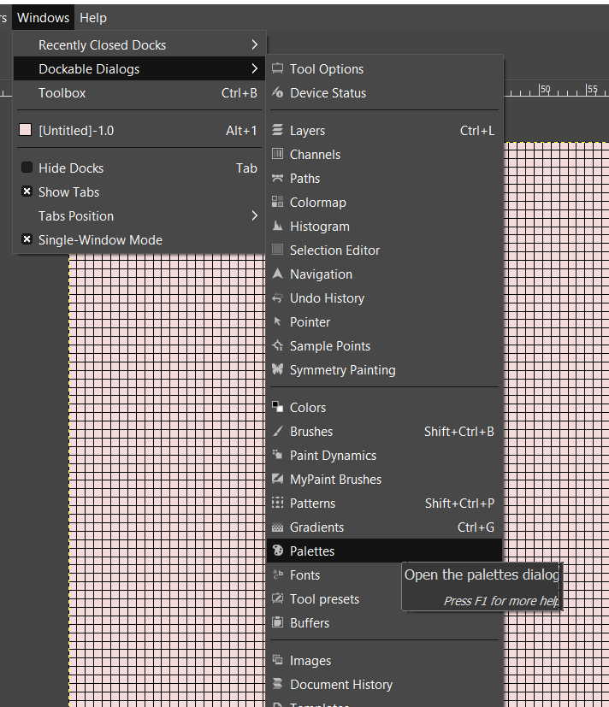
2. Click the **Create a New Palette** button at the new panel.  
     
   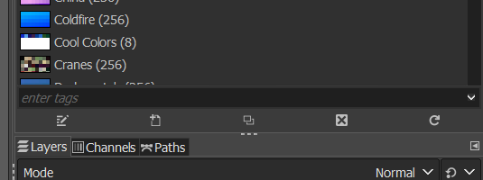
3. Select a black foreground color at the active foreground color panel.
4. Under the Palette Editor click the **Create a new entry from the foreground color button**.
5. Select the 1 template as shown below:  
     
   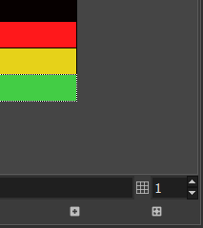
6. Pick a Red, a Yellow and a Green color and add them to the template.

**Design with Pixel Art**

1. Click on the Pencil tool in the Toolset panel.
2. Set the size to 1 and the
3. Pick the black color from the Template and draw the cap of a mushroom.
4. The proceed with the body.
5. Select the Yellow color from the template and the Bucket tool from the Toolset panel.
6. Fill the mushroom’s body with the yellow color.
7. Click on the pencil again and pick the red color from the Palette.
8. Draw a few spots on the cap.
9. The result should be similar to the one below:  
     
   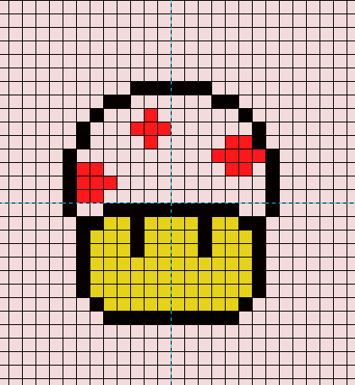
10. Create two Guides and set them to 32 Horizontal and 32 Vertical.
11. Click on the Rectangular tool select the mushroom and move it at the middle of the image, where the guides intersect.
12. Right click on the layer panel and click Add Alpha Channel (watch video).
13. Click on the Fuzzy Select tool and click on the background.
14. Click Edit 🡪 Clear.

Once you complete the previous steps:

|  |
| --- |
| **TASK 1.1:**  Take a screenshot of the mushroom and paste it below: |
|  |

**Exporting and Importing**

1. Click File 🡪 Export.
2. Name the image EvilMushroom and export as png.
3. Double click on the Unity Hub icon.
4. Create a new 2D project and name it, Pixel Art Example.
5. In the new project right click under the Project panel and then Create 🡪 New Folder.
6. Name the folder Characters.
7. Drag and Drop the EvilMushroom in the Characters folder.
8. Drag and drop the EvilMushroom from the Characters folder to the Hierarchy panel.
9. Click on the EvilMushroom and then on the Rect Tool.
10. Enlarge the mushroom and place it in the middle of the projection.
11. Press the Play Button and Check if the character is rendered.
12. (If not reposition the character or the camera).

|  |
| --- |
| **TASK 1.2:**  Take a screenshot of the Game View displaying the EvilMushroom and paste it below: |
|  |

# ACTIVITY 2

## PIXEL ART MORE COMPLEX CHARACTER

This tutorial demonstrates how to design a character using pixel art, under layers.

Follow the steps below:

1. Click File 🡪 New.
2. Set the Width and Height to 48 and press OK.
3. Set the Grid spacing to 1 and then click View 🡪 Show Grid.
4. Click Windows 🡪 Dockable Dialogs 🡪 Palettes.
5. Click on the Create a New Palette button and set the template to 11.
6. Select the colors such as the ones below:  
     
   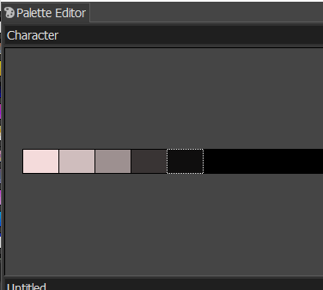
7. Right click on the Layers panel and add a new layer named Head.
8. Pick the White (first color) and draw, with the Pencil tool something such as below:  
     
   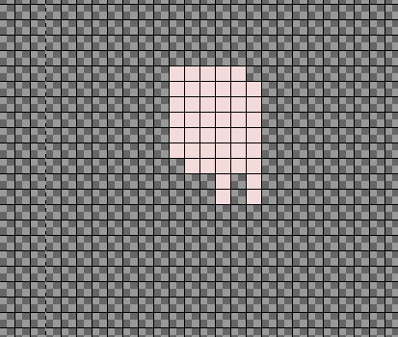
9. Create a new layer and name it Body.
10. Draw the body such as below (be careful with the overlapping parts):  
      
    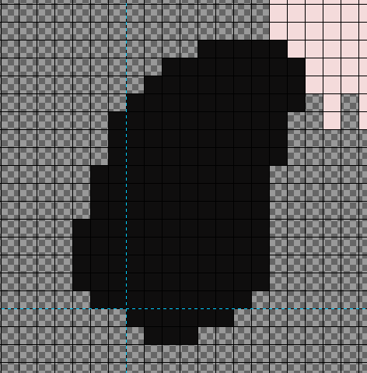
11. Create a new layer and name it Left Arm.
12. Draw something such as the arm below, picking the lighter black color:  
      
    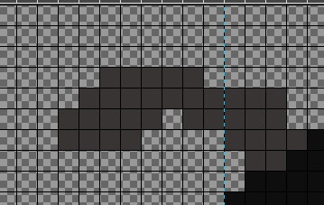
13. Click on the Rectangle tool.
14. Select the Left Arm in the Left Arm layer.
15. Click Ctrl-C and then Ctrl-V.
16. Move the Arm at the lower part of the body.
17. Click on the Flip Tool and execute a Horizontal and a Vertical Flip.
18. Click on the Rotate Tool and rotate the Arm to match the body stance.
19. Move and adjust the Arm such as shown below:  
      
    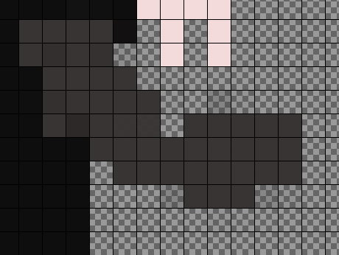
20. Add Arms Claw in the arms layers as shown below:  
      
    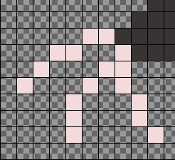 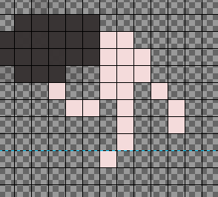
21. Create a new Layer and name it Left Foot.
22. Pick the Pencil and the same color as the Arms and draw the Foot such as below:  
      
    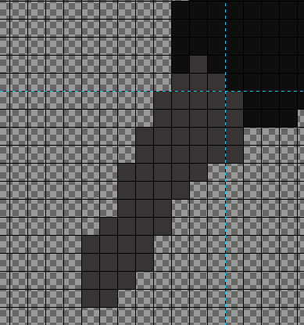
23. Select the Foot with the Rectangular Tool, cut and paste.
24. Flip Horizontally and then Rotate and Move, adjusting to match the torso layer.
25. Right – click on the Floating Selecting and then To New Layer.
26. Name the new layer Right Foot.
27. Pick the darkest colors and add Shading to the character’s face, as shown below:  
      
    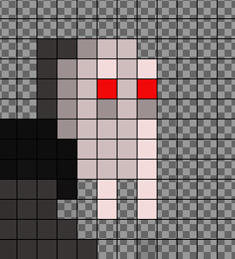
28. Repeat the same process to the Torso.  
      
    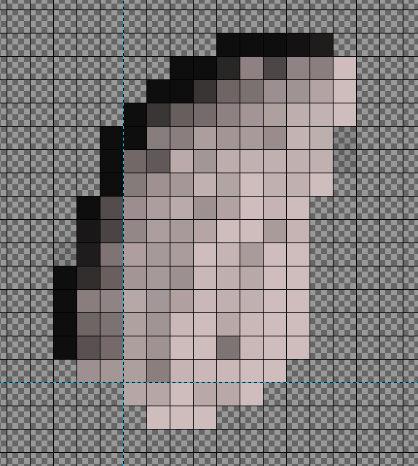
29. Repeat the same process with the Arms and the Feet (use the knowledge from previous tutorials).
30. Add a new Layer and name it Belt.
31. Draw something such as the belt below:  
      
    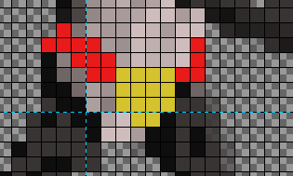

Once you complete the previous steps:

|  |
| --- |
| **TASK 2.1:**  Take a screenshot of the completed project on GIMP and paste it below: |
|  |

1. Click File 🡪 Export as…
2. Name the file CountDracula.png and export as .png.
3. Open the previously created Pixel Art Character project in Unity.
4. Drag and drop the CountDracula image in the Characters folder.
5. Drag and drop the CountDracula image in the Hierarchy.
6. Click on the CountDracula character and then on the Scale tool.
7. Enlarge to make it visilble.
8. Save the Unity project.

Once you complete the previous steps:

|  |
| --- |
| **TASK 2.2:**  Take a screenshot of the Unity Project’s Game View, displaying the CountDracula character and paste it below: |
|  |

# ACTIVITY 3

## PIXEL ART ASSET

This exercise purpose is to practice on pixel art designing a simple asset such as an Axe.

Follow the steps below:

1. Download the Axe.png from the Lab #9 Support Files from E-Centennial.
2. In GIMP create a new Project and import the Axe as a new Layer, named Background.
3. Make the Background later more transparent (Opacity around 50%).
4. Add a new Layer and name it Axe.
5. Draw your edition of the Axe using the Background layer as your guide.
6. Export and Import in Unity using the previously acquired knowledge.

|  |
| --- |
| **TASK 3.1:**  Take a screenshot of the Unity Project’s Game View Displaying the Axe and paste it below: |
|  |

FINAL STEP: Save this document as a PDF. Upload the PDF to the Lab #9 submission folder.